Customer Shopping Behavior Analysis
Data Cleaning (Python) | SQL Analysis | Power BI Dashboard

1. Project Overview
This project analyzes customer shopping behavior using transactional data from 3,900 purchases across various product categories. The goal is to uncover insights into spending patterns, customer segments, product preferences, and subscription behavior to guide strategic business decisions.

2. Dataset Summary
- Rows: 3,900
- Columns: 18
- Missing Data: 37 values in the Review Rating column

Key Features:
Column | Description
Customer ID | Unique identifier for each customer
Age, Gender | Customer demographics
Item Purchased, Category | Product details
Purchase Amount (USD) | Transaction value
Location | Customer's location
Review Rating | Product rating given by customer
Subscription Status | Whether the customer is subscribed
Shipping Type | Shipping method used
Discount Applied, Promo Code Used | Promotion-related flags
Previous Purchases | Number of past purchases by the customer
Frequency of Purchases | How often the customer shops

3. Exploratory Data Analysis using Python
We began with data preparation and cleaning in Python:
- Data Loading: Imported the dataset using pandas.
- Initial Exploration: Used df.info() to check structure and .describe() for summary statistics.
- Missing Data Handling: Checked for null values and imputed missing values in the Review Rating column using the median rating of each product category.
- Column Standardization: Renamed columns to snake case for better readability and documentation.
- Feature Engineering: Created age_group by binning customer ages, and purchase_frequency_days from purchase data.
- Data Consistency Check: Verified that discount_applied and promo_code_used were redundant; dropped promo_code_used.
- Database Integration: Connected the Python script to the database and loaded the cleaned DataFrame for SQL analysis.

Full Python Script
"""
Customer Shopping Behavior Analysis - Data Cleaning & MySQL Load
-------------------------------------------------------------
This script:
1. Loads the raw CSV dataset
2. Cleans missing values
3. Standardizes column names
4. Engineers new features (age_group, purchase_frequency_days)
5. Loads the cleaned data into a MySQL database for SQL analysis
"""
import pandas as pd
from urllib.parse import quote_plus
import os
# --------------------------------------------------
# 1. Load raw data
# --------------------------------------------------
df = pd.read_csv("customer_shopping_behavior.csv")
print(df.head())
print(df.info())
print(df.describe(include="all"))
print("Missing values before cleaning:\n", df.isnull().sum())
# --------------------------------------------------
# 2. Handle missing values
# --------------------------------------------------
# Fill missing Review Rating with the median rating for that product category
df["Review Rating"] = df.groupby("Category")["Review Rating"].transform(
lambda x: x.fillna(x.median())
)
print("Missing values after cleaning:\n", df.isnull().sum())
# --------------------------------------------------
# 3. Standardize column names
# --------------------------------------------------
df.columns = df.columns.str.lower()
df.columns = df.columns.str.replace(" ", "_")
df = df.rename(columns={"purchase_amount_(usd)": "purchase_amount"})
df = df.rename(columns={"location": "location"}) # kept consistent
print(df.columns.tolist())
# --------------------------------------------------
# 4. Feature engineering — age_group
# --------------------------------------------------
labels = ["Young Adult", "Adult", "Middle-aged", "Senior"]
df["age_group"] = pd.qcut(df["age"], q=4, labels=labels)
print(df[["age", "age_group"]].head(10))
# --------------------------------------------------
# 5. Feature engineering — purchase_frequency_days
# --------------------------------------------------
frequency_mapping = {
"Fortnightly": 14,
"Weekly": 7,
"Monthly": 30,
"Quarterly": 90,
"Bi-weekly": 14,
"Annually": 365,
"Every 3 Months": 90,
}
df["purchase_frequency_days"] = df["frequency_of_purchases"].map(frequency_mapping)
print(df[["purchase_frequency_days", "frequency_of_purchases"]].head(10))
# --------------------------------------------------
# 6. Sanity check — discount vs promo code columns
# --------------------------------------------------
print((df["discount_applied"] == df["promo_code_used"]).all())
# --------------------------------------------------
# 7. Load cleaned data into MySQL
# --------------------------------------------------
# IMPORTANT: never hardcode real credentials in a file you push to GitHub.
# Set these as environment variables before running the script, e.g.:
# export DB_NAME=customer_shopping_behavior
db_name = os.environ.get("DB_NAME", "customer_shopping_behavior")
print("Connected to MySQL successfully")
df.to_sql(
name="customer_shopping_behavior",
con=engine,
if_exists="replace",
index=False,
)
print("Data loaded into MySQL successfully")

Pandas Output
Below are the actual outputs produced while running the cleaning script in Jupyter Notebook.
df.head() — first 5 rows
ID | Age | Gender | Item | Category | Amount | Rating | Subscribed
1 | 55 | Male | Blouse | Clothing | 53 | 3.1 | Yes
2 | 19 | Male | Sweater | Clothing | 64 | 3.1 | Yes
3 | 50 | Male | Jeans | Clothing | 73 | 3.1 | Yes
4 | 21 | Male | Sandals | Footwear | 90 | 3.5 | Yes
5 | 45 | Male | Blouse | Clothing | 49 | 2.7 | Yes
(Showing key columns only — full dataset has 18 columns.)
df.info()
RangeIndex: 3900 entries, 0 to 3899
Data columns (total 18 columns):
Customer ID 3900 non-null int64
Age 3900 non-null int64
Gender 3900 non-null object
Item Purchased 3900 non-null object
Category 3900 non-null object
Purchase Amount (USD) 3900 non-null int64
Location 3900 non-null object
Size 3900 non-null object
Color 3900 non-null object
Season 3900 non-null object
Review Rating 3863 non-null float64
Subscription Status 3900 non-null object
Shipping Type 3900 non-null object
Discount Applied 3900 non-null object
Promo Code Used 3900 non-null object
Previous Purchases 3900 non-null int64
Payment Method 3900 non-null object
Frequency of Purchases 3900 non-null object
dtypes: float64(1), int64(4), object(13)
memory usage: 548.6+ KB
df.describe() — summary statistics (key numeric columns)
 | Age | Purchase Amount | Review Rating | Previous Purchases
mean | 44.07 | 59.76 | 3.75 | 25.35
std | 15.21 | 23.69 | 0.72 | 14.45
min | 18 | 20 | 2.5 | 1
25% | 31 | 39 | 3.1 | 13
50% | 44 | 60 | 3.8 | 25
75% | 57 | 81 | 4.4 | 38
max | 70 | 100 | 5.0 | 50
df.isnull().sum() — before cleaning
Column | Missing Values
Review Rating | 37
All other columns | 0
df.isnull().sum() — after cleaning (median imputation by category)
Column | Missing Values
All columns (including Review Rating) | 0
age_group — sample output
Age | age_group
55 | Middle-aged
19 | Young Adult
50 | Middle-aged
21 | Young Adult
45 | Middle-aged
63 | Senior
purchase_frequency_days — sample output
Frequency of Purchases | purchase_frequency_days
Fortnightly | 14.0
Weekly | 7.0
Annually | 365.0
Quarterly | 90.0
Discount Applied vs Promo Code Used — consistency check
(df['Discount Applied'] == df['Promo Code Used']).all() → True
Confirms both columns always carry identical Yes/No values, so promo_code_used was dropped as redundant.

4. Data Analysis using SQL (Business Transactions)
We performed structured analysis in SQL to answer key business questions:

1. Revenue by Gender
Compared total revenue generated by male vs. female customers.
SELECT gender, SUM(`Purchase Amount (USD)`) AS revenue
FROM customer_shopping_behavior
GROUP BY gender;
gender | revenue
Female | 75,191
Male | 157,890
Male customers generate more than double the revenue of female customers.

2. High-Spending Discount Users
Identified customers who used discounts but still spent above the average purchase amount.
SELECT customer_id, `Purchase Amount (USD)`
FROM customer_shopping_behavior
WHERE discount_applied = 'Yes'
AND `Purchase Amount (USD)` >= (SELECT AVG(`Purchase Amount (USD)`) FROM customer_shopping_behavior);
customer_id | purchase_amount
2 | 64
3 | 73
4 | 90
7 | 85
9 | 97
12 | 68
13 | 72
16 | 81
20 | 90
22 | 62
839 rows returned in total — a sizeable segment of high-value, discount-using customers.

3. Top 5 Products by Rating
Found products with the highest average review ratings.
SELECT item_purchased, ROUND(AVG(review_rating), 2) AS "Average Product Rating"
FROM customer_shopping_behavior
GROUP BY item_purchased
ORDER BY AVG(review_rating) DESC
LIMIT 5;
item_purchased | Average Product Rating
Gloves | 3.86
Sandals | 3.84
Boots | 3.82
Hat | 3.80
Skirt | 3.78

4. Shipping Type Comparison
Compared average purchase amounts between Standard and Express shipping.
SELECT shipping_type, ROUND(AVG(`Purchase Amount (USD)`), 2) AS avg_purchase
FROM customer_shopping_behavior
WHERE shipping_type IN ('Standard', 'Express')
GROUP BY shipping_type;
shipping_type | avg_purchase
Standard | 58.46
Express | 60.48

5. Subscribers vs. Non-Subscribers
Compared average spend and total revenue across subscription status.
SELECT subscription_status, COUNT(customer_id) AS total_customers,
ROUND(AVG(`Purchase Amount (USD)`), 2) AS avg_spend,
ROUND(SUM(`Purchase Amount (USD)`), 2) AS total_revenue
FROM customer_shopping_behavior
GROUP BY subscription_status;
subscription_status | total_customers | avg_spend | total_revenue
Yes | 1053 | 59.49 | 62,645.00
No | 2847 | 59.87 | 170,436.00

6. Discount-Dependent Products
Identified the 5 products with the highest percentage of discounted purchases.
SELECT item_purchased,
ROUND(100.0 * SUM(CASE WHEN discount_applied = 'Yes' THEN 1 ELSE 0 END) / COUNT(*), 2) AS discount_rate
FROM customer_shopping_behavior
GROUP BY item_purchased
ORDER BY discount_rate DESC
LIMIT 5;
item_purchased | discount_rate
Hat | 50.00
Sneakers | 49.66
Coat | 49.07
Sweater | 48.17
Pants | 47.37

7. Customer Segmentation
Classified customers into New, Returning, and Loyal segments based on purchase history.
SELECT customer_segment, COUNT(*) AS "Number of Customers"
FROM (
SELECT customer_id, previous_purchases,
CASE
WHEN previous_purchases = 1 THEN 'New'
WHEN previous_purchases BETWEEN 2 AND 10 THEN 'Returning'
ELSE 'Loyal'
END AS customer_segment
FROM customer_shopping_behavior
) sub
GROUP BY customer_segment;
customer_segment | Number of Customers
Loyal | 3,116
New | 83
Returning | 701

8. Top 3 Products per Category
Listed the most purchased products within each category.
SELECT item_rank, category, item_purchased, total_orders FROM (
SELECT category, item_purchased, COUNT(*) AS total_orders,
RANK() OVER (PARTITION BY category ORDER BY COUNT(*) DESC) AS item_rank
FROM customer_shopping_behavior
GROUP BY category, item_purchased
) ranked
WHERE item_rank <= 3;
category | item_purchased | total_orders
Accessories | Jewelry | 171
Accessories | Sunglasses | 161
Accessories | Belt | 161
Clothing | Blouse | 171
Clothing | Pants | 171
Clothing | Shirt | 169
Footwear | Sandals | 160
Footwear | Shoes | 150
Footwear | Sneakers | 145
Outerwear | Jacket | 163
Outerwear | Coat | 161

9. Repeat Buyers & Subscriptions
Checked whether customers with more than 5 previous purchases are more likely to subscribe.
SELECT subscription_status, COUNT(*) AS repeat_buyers
FROM customer_shopping_behavior
WHERE previous_purchases > 5
GROUP BY subscription_status;
subscription_status | repeat_buyers
No | 2,518
Yes | 958
Most repeat buyers are still non-subscribers — subscription is not the main driver of repeat purchasing.

10. Revenue by Age Group
Calculated the total revenue contribution of each age group.
SELECT age_group, SUM(`Purchase Amount (USD)`) AS total_revenue
FROM customer_shopping_behavior
GROUP BY age_group
ORDER BY total_revenue DESC;
age_group | total_revenue
Young Adult | 62,143
Middle-aged | 59,197
Adult | 55,978
Senior | 55,763
Revenue is fairly evenly spread across age groups, with Young Adults contributing slightly more.

5. Dashboard in Power BI
Finally, we built an interactive dashboard in Power BI to present insights visually.
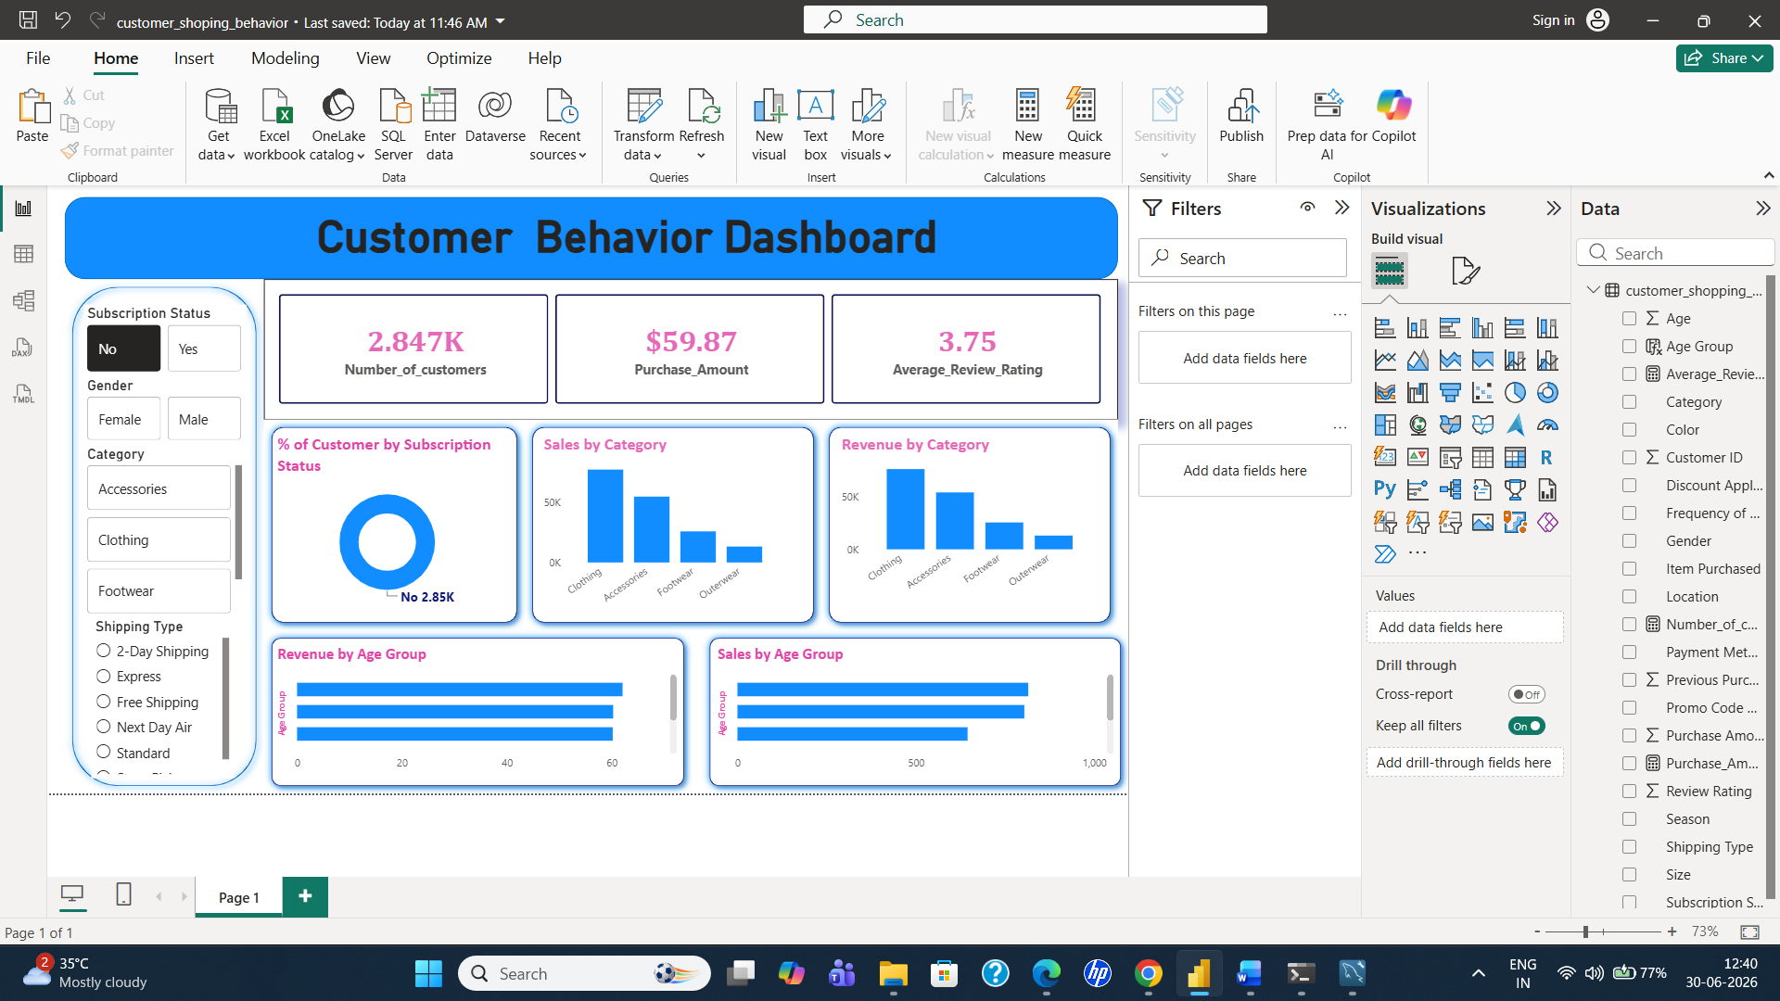
Customer Behavior Dashboard — Power BI

6. Business Recommendations
- Boost Subscriptions — Promote exclusive benefits for subscribers, since current subscribers don't show meaningfully higher spend — the program needs a stronger value proposition.
- Customer Loyalty Programs — Reward repeat buyers to move them further into the “Loyal” segment and protect this base, which already drives the majority of revenue.
- Review Discount Policy — Balance sales boosts with margin control, especially for high discount-rate products like Hats and Sneakers, which are heavily discount-dependent.
- Product Positioning — Highlight top-rated and best-selling products (Gloves, Sandals, Boots, Jewelry, Blouse) in marketing campaigns.
- Targeted Marketing — Focus efforts on high-revenue age groups (Young Adult, Middle-aged) and Express-shipping users, who tend to spend more.

Tech Stack
Python | Pandas | SQLAlchemy | PyMySQL | SQL (MySQL / PostgreSQL) | Power BI

